Pune Institute of Computer Technology, Pune

Department of Computer Engineering

A.Y. 2020-21 Semester: I

Database Management System Lab

Name: Aditya Sawant

Roll No: 31302

Batch: K3

ASSIGNMENT 2

TITLE:

Design and Develop SQL DDL statements which demonstrate the use of SQL objects such as creation of (Table, View, Index, Sequence, Synonym).

PROBLEM DEFINITION:

Implement DDL commands in context of view, index, sequence using JDBC.

OBJECTIVE:

* To understand implementation of JDBC.
* To understand & implement the various DDL and DML Commands.
* To understand database concepts like view, index ,sequence and synonym.

OUTCOME:

We will be able to understand and implement DDL and DML commands using JDBC.

HARDWARE REQUIREMENTS:

* MONITOR
* KEYBOARD
* 2GB RAM
* 2.4GHz I5 PROCESSOR

SOFTWARE REQUIREMENTS:

* DATABASE-MYSQL
* IDE-ECLIPSE
* OS-FEDORA 20

Theory:

JDBC:

Java Database Connectivity (JDBC) is an application programming interface (API) for the programming language Java, which defines how a client may access a database. It is a Java-based data access technology used for Java database connectivity. It is part of the Java Standard Edition platform, from Oracle Corporation.

STEPS INVOLVED IN JDBC:

## The fundamental steps involved in the process of connecting to a database and executing a query consist of the following:

1. Import JDBC packages.
2. Load and register the JDBC driver.
3. Open a connection to the database.
4. Create a statement object to perform a query.
5. Execute the statement object and return a query resultset.
6. Process the resultset.
7. Close the resultset and statement objects.
8. Close the connection.

Applications of JDBC:

Fundamentally, JDBC is a specification that provides a complete set of interfaces that allows for portable access to an underlying database. Java can be used to write different types of executables, such as −

* Java Applications
* Java Applets
* Java Servlets
* Java ServerPages (JSPs)
* Enterprise JavaBeans (EJBs).

INDEX:

An index can be created in a table to find data more quickly and efficiently. The users cannot see the indexes, they are just used to speed up searches/queries.

SYNTAX-

CREATE INDEX index_name ON table_name (column_name);

SEQUENCE:

A sequence is a set of integers 1, 2, 3, ... that are generated in order on a specific demand. Sequences are frequently used in the databases because many applications require each row in a table to contain a unique value and sequences provide an easy way to generate them.

The simplest way in MySQL to use Sequences is to define a column as AUTO_INCREMENT and leave the remaining things to MySQL to take care.

SYNTAX-

CREATE Sequence sequence-name start with initial-value increment by increment-value maxvalue maximum-value cycle|nocycle

SYNONYM:

Synonyms provide both data independence and location transparency. Synonyms permit applications to function without modification regardless of which user owns the table or view and regardless of which database holds the table or view. However, synonyms are not a substitute for privileges on database objects. Appropriate privileges must be granted to a user before the user can use the synonym.

SYNTAX-

Use the CREATE SYNONYM statement to create a synonym

Code:

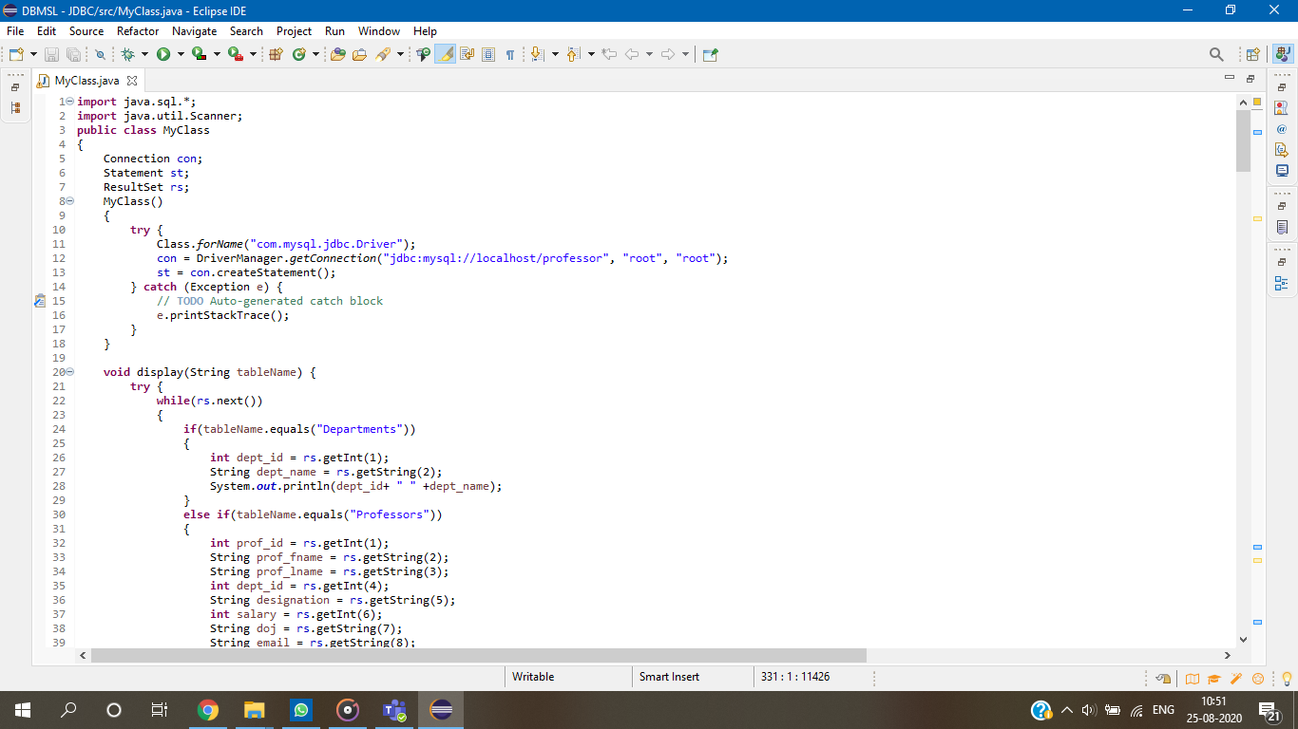

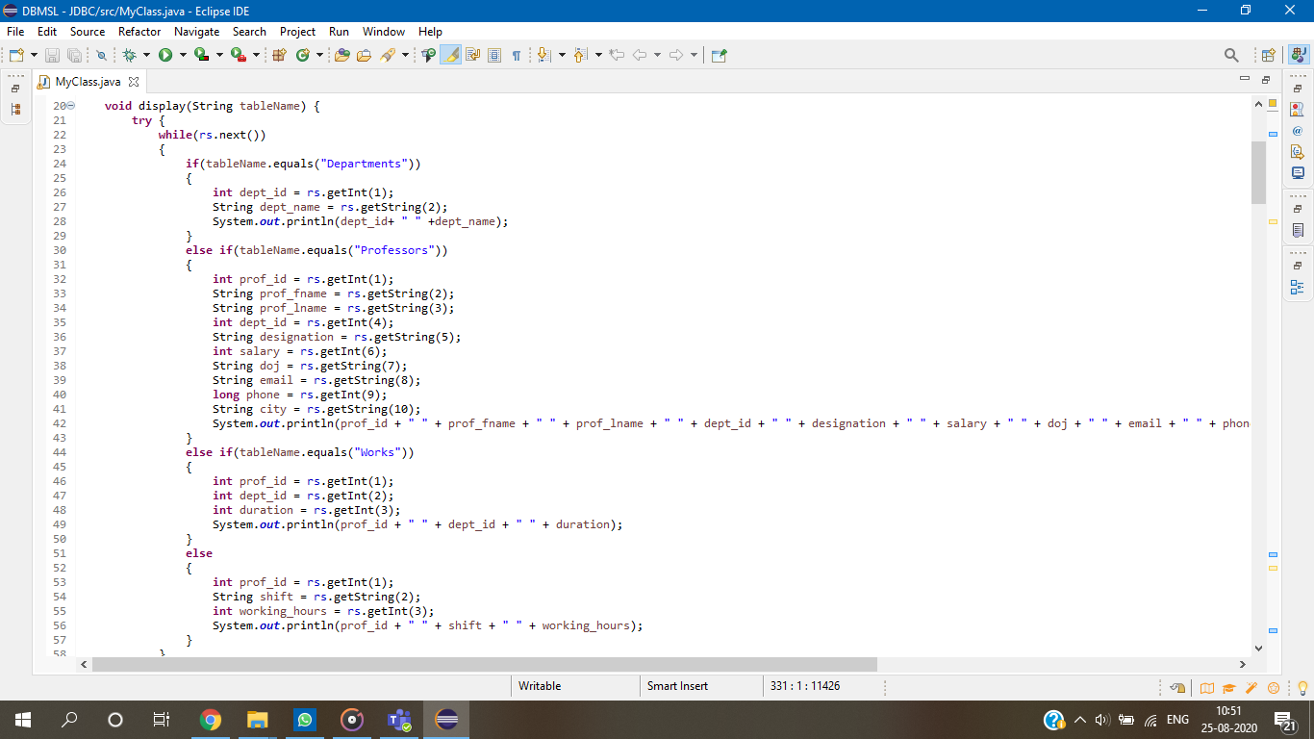

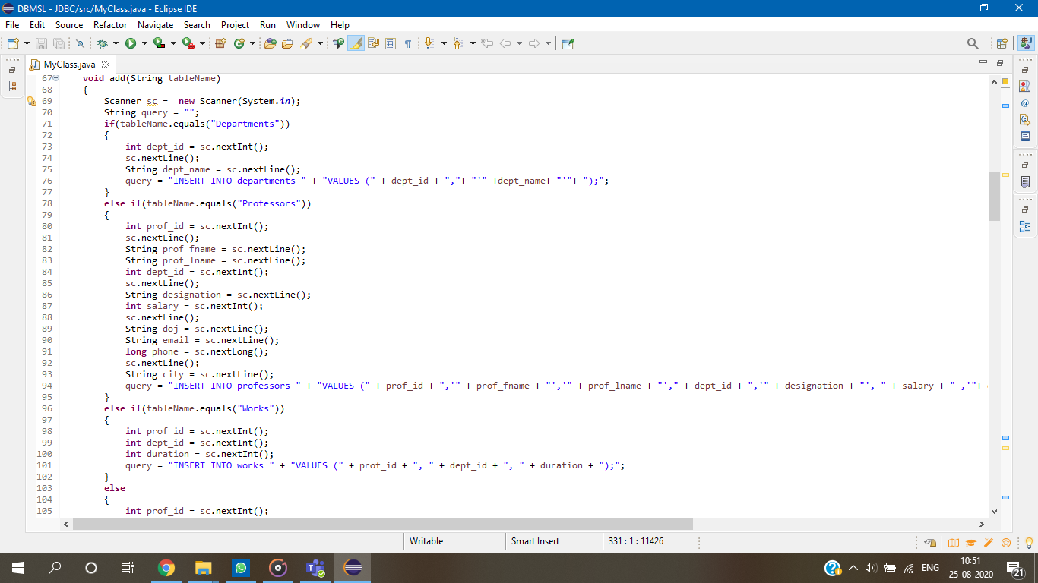

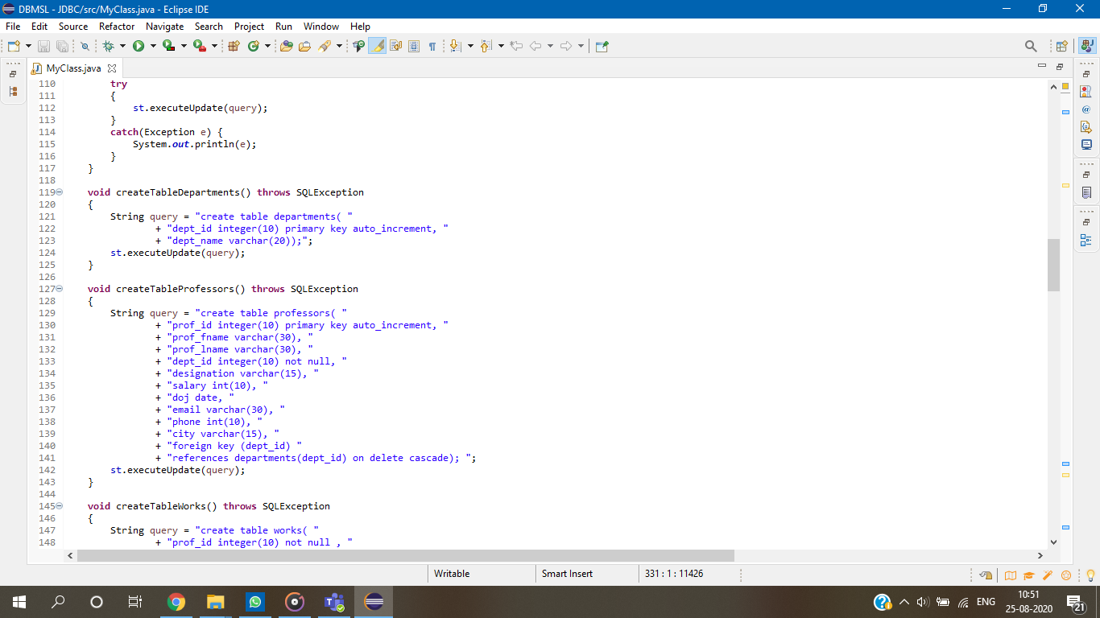

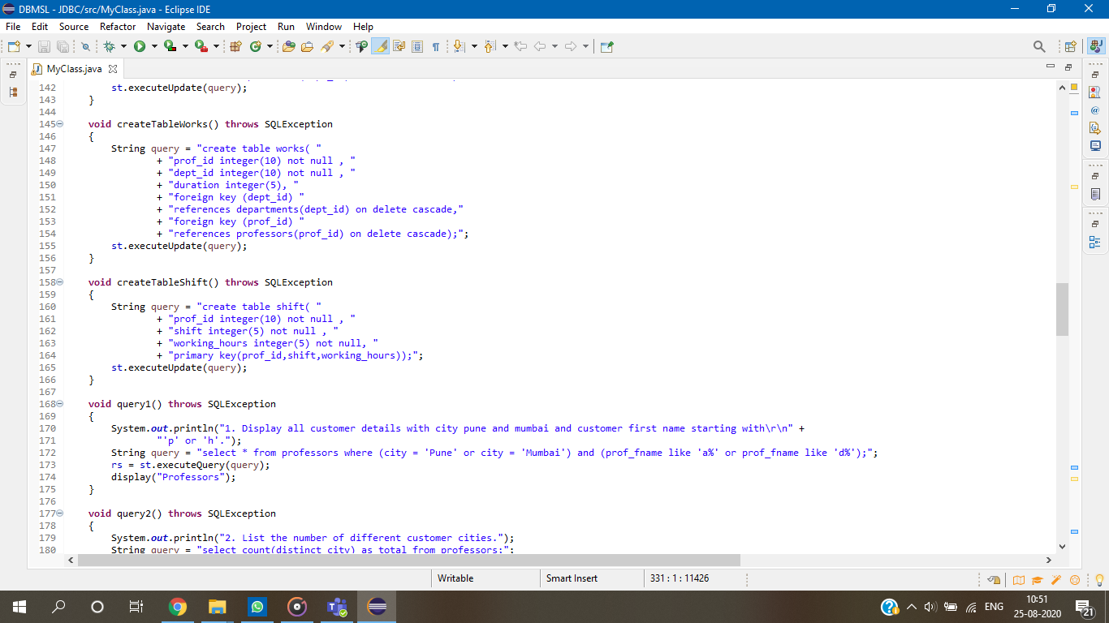

Outputs:

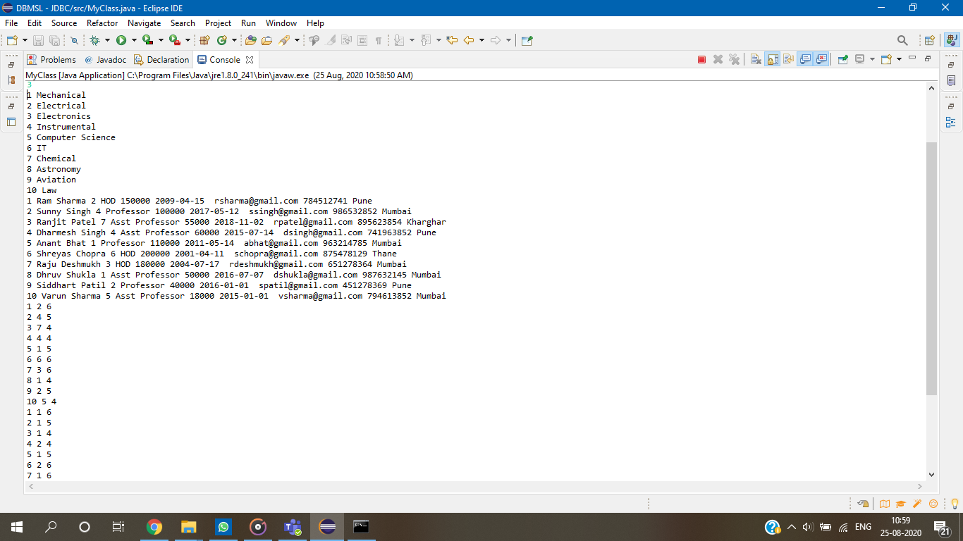

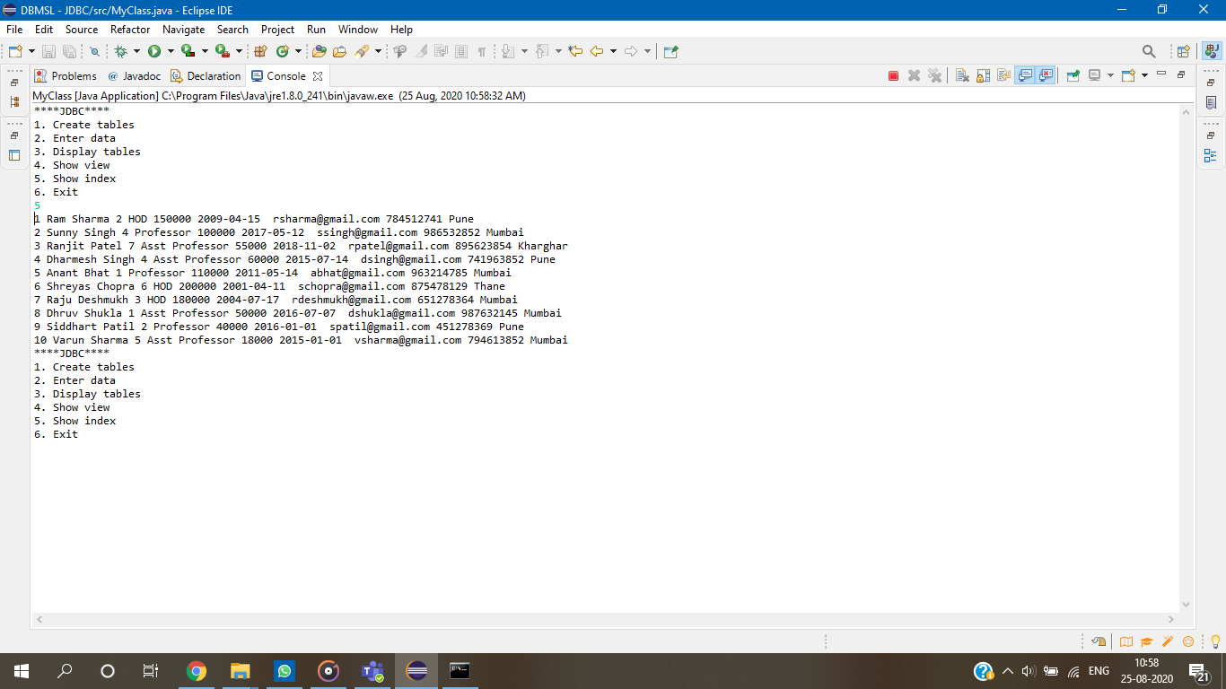

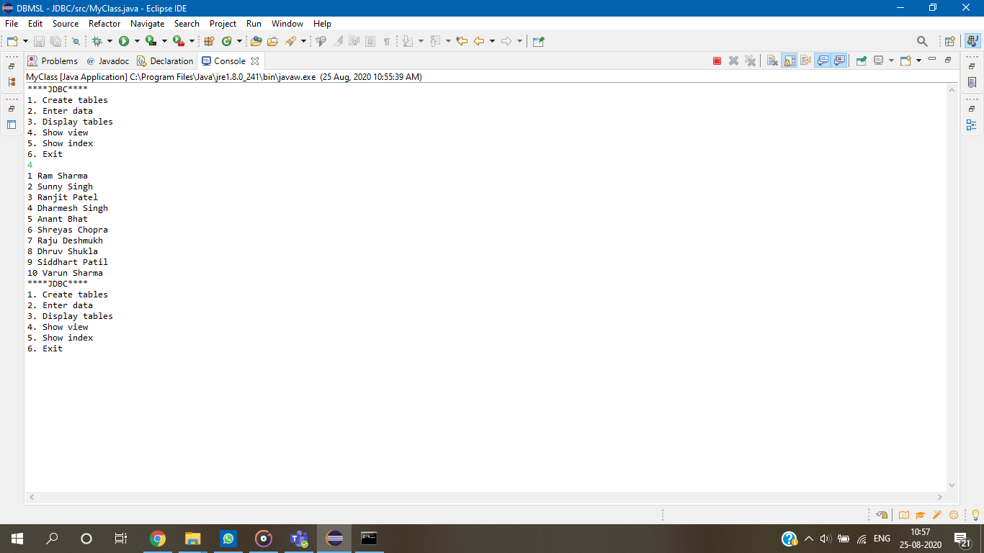

CONCLUSION:

WE HAVE SUCCESSFULLY UNDERSTOOD CONCEPTS OF VIEW, INDEXING , SEQUENCE AND SYNONYM AND IMPLEMENTED DDL AND DML COMMANDS USING JDBC.